

**Object Oriented Programming**

**Lab Task 2**

**SUBMITTED BY:**

Hasaan Ahmad SP22-BSE-017

**SUBMITTED TO: Sir Muzaffar Iqbal**

**Solved Lab Activity 1:**

package Lab2;

class Rectangle {

    public int length, width;

    public int Calculatearea() {

        return (length * width);

    }

}

public class runner {

    public static void main(String args[]) {

        Rectangle rect = new Rectangle();

        rect.length = 10;

        rect.width = 5;

        System.out.println(rect.Calculatearea());

    }

}

**Output:**

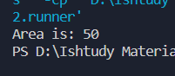

**Solved Lab Activity 2:**

package Lab2;

class Rectangle {

    public int length, width;

    public Rectangle() {

        length = 5;

        width = 2;

    }

    public Rectangle(int l, int w) {

        length = l;

        width = w;

    }

    public int Calculatearea() {

        return (length * width);

    }

}

public class runner2 {

    public static void main(String args[]) {

        Rectangle rect = new Rectangle();

        System.out.println(rect.Calculatearea());

        Rectangle rect1 = new Rectangle(10, 20);

        System.out.println(rect1.Calculatearea());

    }

}

**Output:**

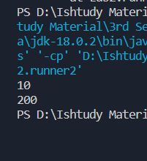

**Solved Lab Activity 3:**

package Lab2;

class Point {

    private int x;

    private int y;

    public Point() {

        x = 1;

        y = 2;

    }

    public Point(int a, int b) {

        x = a;

        y = b;

    }

    public void setX(int a) {

        x = a;

    }

    public void setY(int b) {

        y = b;

    }

    public void display() {

        System.out.println("x coordinate = " + x + " y coordinate = "

                + y);

    }

    public void movePoint(int a, int b) {

        x = x + a;

        y = y + b;

        System.out.println("x coordinate after moving = " + x + " y coordinate after moving = " + y);

    }

}

public class runner3 {

    public static void main(String args[]) {

        Point p1 = new Point();

        p1.movePoint(2, 3);

        p1.display();

        Point p2 = new Point();

        p2.movePoint(2, 3);

        p2.display();

    }

}

**Output:**

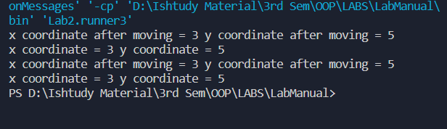

**Graded Lab Task 1:**

package Lab2;

public class GLT1 {

    public static void main(String[] args) {

        Circle c1 = new Circle(); // Create a Circle object with radius 0.0

        Circle c2 = new Circle(2.5); // Create a Circle object with radius 2.5

        double cir1 = c1.calculateCircumference();

        double cir2 = c2.calculateCircumference();

        System.out.println(cir1);

        System.out.println(cir2);

    }

}

class Circle {

    private double radius;

    public Circle() {

        radius = 0.0;

    }

    public Circle(double r) {

        radius = r;

    }

    public double calculateCircumference() {

        return 2 * Math.PI * radius;

    }

}

**Output:**

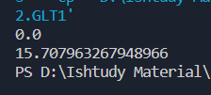

**Graded Lab Task 2:**

package Lab2;

class Account {

    double balance;

    public Account(double bal) {

        balance = bal;

    }

    public Account() {

        balance = 5000; // As default, balance= 5000

    }

    void withdraw(double amount) {

        balance -= amount;

    }

    void deposit(double amount) {

        balance += amount;

    }

    void display() {

        System.out.println("The total balance is " + balance);

    }

}

public class GLT2 {

    public static void main(String[] args) {

        Account a1 = new Account(50000);

        Account a2 = new Account();

        a1.display();

        a2.display();

        a2.deposit(5000);

        a2.display();

        a2.withdraw(1000);

        a2.display();

    }

}

**Output:**

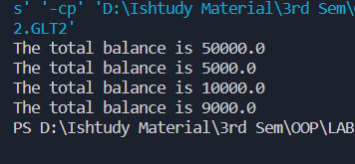

**Graded Lab Task 3:**

package Lab2;

public class GLT3 {

    public static void main(String[] args) {

        Distance d1 = new Distance();

        Distance d2 = new Distance(5, 8);

        d1.displayDistance();

        d2.displayDistance();

    }

}

class Distance {

    double feet;

    double inches;

    public Distance() {

        // Default constructor for distance

        feet = 10.0;

        inches = 10.0;

    }

    public Distance(double feetIn, double inchesIn) {

        feet = feetIn;

        inches = inchesIn;

    }

    void displayDistance() {

        System.out.println("Distance: " + feet + " inches : " + inches);

    }

}

**Output:**

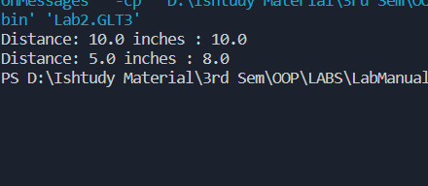

**Graded Lab Task 4:**

package Lab2;

public class GLT4 {

    public static void main(String[] args) {

        Marks m1 = new Marks();

        Marks m2 = new Marks(80, 60, 90);

        System.out.println(m1.calulateSum());

        System.out.println(m2.calulateSum());

    }

}

class Marks {

    int EngMarks;

    int CompMarks;

    int BioMarks;

    Marks() {

        // Default constructor

        EngMarks = 50;

        CompMarks = 50;

        BioMarks = 50;

    }

    Marks(int eng, int comp, int bio) {

        EngMarks = eng;

        CompMarks = comp;

        BioMarks = bio;

    }

    int calulateSum() {

        int sum = EngMarks + CompMarks + BioMarks;

        return sum;

    }

}

**Output:**

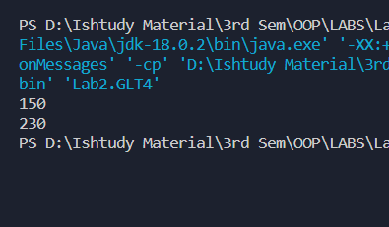

**Graded Lab Task 5:**

package Lab2;

public class GLT5 {

    public static void main(String[] args) {

        Time t1 = new Time();

        Time t2 = new Time(23, 22, 40);

        Time t3 = new Time(20, 22, 40);

        t1.display();

        t2.display();

        t3.display();

    }

}

class Time {

    int hours;

    int minutes;

    int seconds;

    public Time() {

        isValidTime(0, 0, 0);

    }

    public Time(int hours, int minutes, int seconds) {

        if (isValidTime(hours, minutes, seconds)) {

            this.hours = hours;

            this.minutes = minutes;

            this.seconds = seconds;

        }

    }

    public static boolean isValidTime(int hours, int minutes, int seconds) {

        // check if the hours, minutes, and seconds are within the valid range

        if (hours >= 0 && hours < 24 && minutes >= 0 && minutes < 60 && seconds >= 0 && seconds < 60) {

            return true;

        } else {

            return false;

        }

    }

    public void display() {

        System.out.printf("%02d:%02d:%02d\n", hours, minutes, seconds);

    }

}

**Output:**

